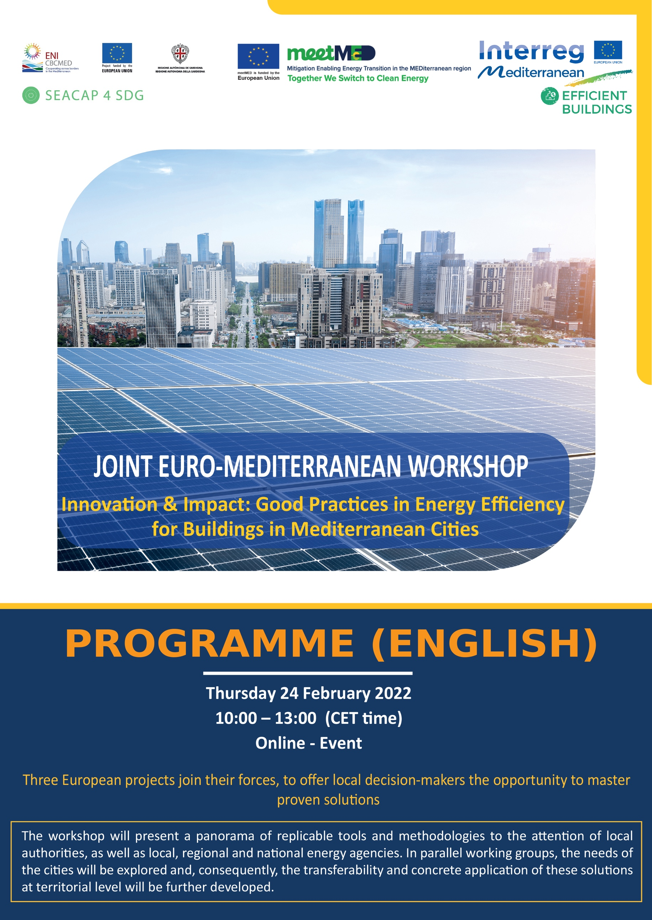
[REGISTER]

10:00 | Introduction and welcome from the 3 projects  Objectives of the workshop
10:15 | Panorama of instruments  Identified by meetMED, the Efficient Buildings and the SEACAP 4 SDG Communities
11:00 | The art of replication  Testimonies from cities that have implemented a methodology/tool
11:15 | Coffee break (15 minutes)
11:30 | Work in parallel groups around several key topics
Construction, renovation, management and maintenance of municipal buildings
Working group I: Energy management of public buildings | - Development and operation of a municipal energy management tool (TBGE): a Tunisian case.  - Italian-Algerian partnership for the testing of the tool of the PrioritEE project in Algeria.
Working group II: Retrofit of public buildings | - Deep building refurbishment: IMPULSE project.  - Energy renovation of schools: Teeschool project.
Promoting the energy efficiency of buildings at local level
Working Group III: Enforcement of the national energy building regulation and urban planning | - Mechanism for the application of Morocco’s thermal regulation at local level.  - Local incentives to encourage compliance with national regulation.
Working Group IV: Catalysing, counselling, and engaging territorial stakeholders | - Energy Information Centre in Morocco.  - Living Labs for the co-creation of Energy Management Initiatives.
National support facilities for municipalities
Working Group V: Financial support mechanisms | - Energy Transition Fund in Tunisia.  - Innovative model and mechanism for financing energy saving projects: SISMA project.
Working Group VI: Training, capacity building and networking | - City network Rev’ACTE.  - Intermunicipal cooperation in Lebanon.  - Energy efficiency training scheme for Palestinian municipalities in partnership with the Municipal Fund.
12:30 | Screen break
12:35 | Seize the opportunity & conclusions  How to get engaged and mobilise support?

