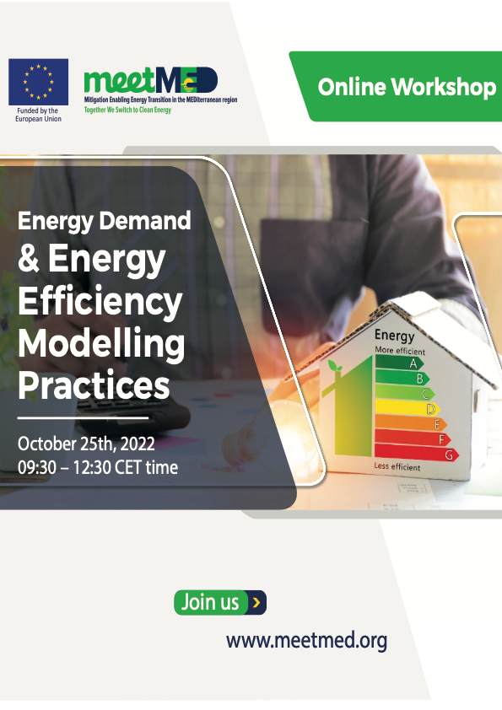
[Document title]
[Document subtitle]

First on-line workshop on energy demand and energy efficiency modelling practices (A2.4)

Date: October 25th, 2022, 9:30 – 12:30 CET time
Location: online meeting
Zoom link to be sent to registrants

An event organized by ADEME in cooperation with RCREEE.

The event is organized as part of the activities of meetMED II (Mitigation Enabling Energy Transition in the Mediterranean Region), second phase, an EU-funded project developed by MEDENER and RCREEE.

Background/ Overview
Energy modelling on energy demand, energy efficiency, and renewable energy is an important tool to assist decision-makers in their policies’ design and implementation. Practices are in place in the beneficiary countries of the meetMED project through national and regional modelling initiatives (OME, Mediterranean Observatory of Energy).
Apart from academic works, energy modelling is performed within meetMED affiliated energy agencies or within the ministries using different models, and energy efficiency scenarios.
As part of the meetMED activity (A2.4) on “Support to policy/decision makers on Monitoring & Evaluation” of policies in the Building and Appliances sectors that they lead, ADEME and RECREE have carried out a survey among meetMED members to select a series of topics to be discussed during three workshops planned on energy modelling. This list has been endorsed by the experts during the kick-off meeting of the activity.
The aim of this 1st workshop is to initiate the dialogue among meetMED practitioners about three topics (see agenda). Since in general these modelling activities are developed jointly with relevant ministries, this workshop is opened at the discretion of the meetMED national experts to their relevant ministries, academics, and data providers.
Conclusions will be presented during the COP27 in Egypt.

Participating countries: Algeria, Egypt, Jordan, Lebanon, Morocco, Palestine, Tunisia, invited: Libya. Other relevant stakeholders (ministries, academics etc.) can also participate.

Agenda

Opening remarks:
- Alessandro Federici, Work Package 2 Leader (Strategies & Policies), ENEA
- Dr Didier Bosseboeuf, Activity 2.4 Leader (Monitoring & Evaluation), ADEME
Session 1 - Overview of models used for demand projection (econometric, bottom-up, hybrid): pro and cons
- Introduction: Pr Bruno Lapillonne (Enerdata, France) (20 mn)
- Example of bottom-up model: EnerMed Afef Jaafar (ANME, Tunisia) (15 mn)
- Models used by APRRUE for forecasting studies : Wahida Klouche, APRUE, 10 mns)
- Data collection: link with data base on indicators Florent Gauthier (Enerdata) (5mn)
- Round table all participants (15 mn)

Session 2 - Combination with energy supply and macro sectorial models
- Introduction : Bruno Lapillonne (Enerdata) (5 mn)
- Energy supply: Case of EnerNeo Algeria, Aurélien Peffen (Enerdata) (20 mn)
- Macro sectorial model: Case of ThreeMee : Meriem Hamdi-Cherif (OFCE) (20 mn)
- Round table all participants (15 mn)

Recap and conclusion: upcoming activities and next step (Didier Bosseboeuf, ADEME)

- For any further information, please contact
Didier.bosseboeuf@ademe.fr
Florent.gauthier@enerdata.fr

